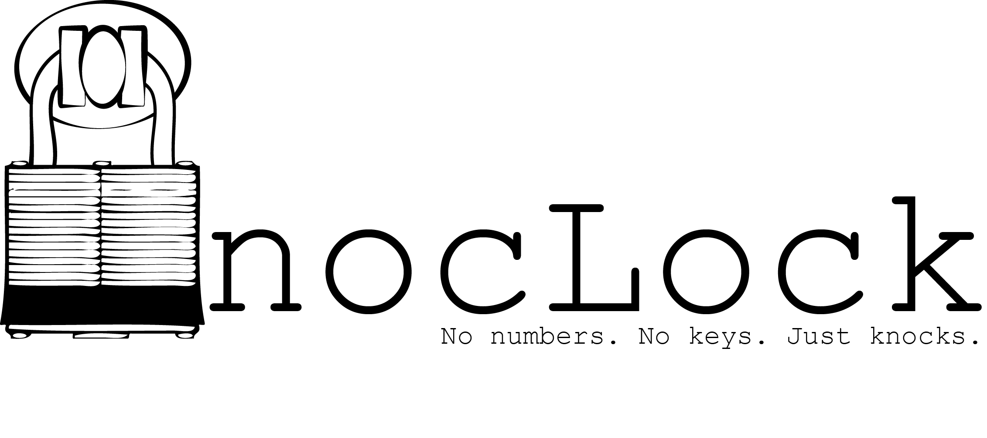

**T02**

Team Members:  
Travis Berger  
Sean Koppenhafer

Jaime Rodriguez

Cameron Tribe

**Abstract**

The nocLock is a safe that is controlled by a specific knock sequence. The user creates a unique knock sequence that is stored by the device. To unlock the device the user must enter the same knock sequence. This device is meant to be a novel semi-secure product that appeals to consumers of all ages.

**Marketing Requirements**

1. Device must lock and unlock.
2. Device must differentiate between many distinct knock sequences
3. Device must be reliable.
4. Device should be user friendly.
5. Device must be safe.
6. Device must be affordable.
7. Device must be durable.
8. Device cannot require additional service.

**Engineering Requirements**

**Functionality**

Must be able to read and store a knock sequence.

Must be able to lock and unlock when the correct knock sequence is inputted.

Should have intuitive user interface that conveys to the user where they are at in the program.

**Performance**

Must be able to store up to 100 knocks in a single sequence

Must be able to differentiate between different knock sequences

Should be able to store a knock sequence after being powered down

**Economic**

Must not exceed $20 in production costs.

**Energy**

Must have an average power consumption of …

Must have peak current consumption of <AMPz>

May have an emergency back-up power supply.

**Health & Safety**

Must have the circuit board enclosed to hide it from the user

Must have approved power tolerances on all components

Must be safe to leave on for long periods of time  
  
Must be made from non toxic materials

**Legal**

**Environmental**

Must be made with non toxic/hazardous chemicals that would require proper disposal.

**Maintainability**

Must have minimal user maintenance over entire life cycle.

Should be easy for user to maintain power supply. <Batteries or wall power etc.> I don't like how this is worded

**Manufacturability**

Must use a two layer PCB that is between 1 and 16 square inches, with no side of the board being less than one inches or more than twelve inches. <Added by Travis, This is straight from 411 Project.pdf>

**Operational**

Must have <SIZE DIMENSIONS>

Must be portable for user <WEIGHT DIMENSIONS> I don't think the safe needs to be portable

**Reliability & Availability**

Must be reliable for complete life cycle. Ex. 98% uptime during lifetime

**Social & Cultural**

**Political**

**Usability**

Must be easy for user to learn how to operate device

Must work the same every time the user uses the device.

**Documentation**

Must have some form of instructions for the user.

Should have instructions on device or method of finding instructions on device.

May have website that provides instructions for the device.

**Validation**

|  |  |  |
| --- | --- | --- |
| **Marketing Requirements** | **Engineering Requirements** | **Justification** |
| 1,2,3 | Must be able to read and store a knock sequence. Must be able to lock and unlock if user enters stored knock sequence. | These requirements establish the basic functionality of the device. |
| 2 | Must be able to store up to 100 knocks in a sequence. Must be able to differentiate between different knock sequences. | These performance requirements establish a maximum number of knocks that can be recorded in a knock sequence |
| 3 | Should be able to restore a knock sequence after losing power | This ensures that the product will be dependable and has safeguards against failures. |
| 7 | Must not exceed <Dollar amount> production costs. | This is the maximum production cost that will ensure that the product is affordable. |
| 3,7 | Must have an average power consumption of <WATTS>. | This is the minimum amount of power for device to perform properly without consuming excess amounts of power. |
| 7 | Must have peak current consumption of <AMPz>. |  |
| 5 | Must have packaged circuitry protected from user. | This protects user from exposed circuitry that could potentially burn or cut them. |
| 5 | Must be safe to leave on for long periods of time. | This device must be left on for long periods of time and still meet safety requirements. |
| 5 | Must be made from non-toxic materials. | This device must be made with materials that are safe for users to operate. |
| 5,7 | Must be made with non toxic/hazardous chemicals that would require proper disposal. | Disposing of hazardous/toxic materials during fabrication would raise production costs. |
| 3,7,8 | Must have minimal user maintenance over entire life cycle. | This device must be designed to be dependable and durable throughout its life cycle. Servicing or repairs would drive the cost too high. |
| 7, | Should be easy for user to maintain power supply. <Batteries or wall power etc.> | <Probably getting rid of this> |
|  | Must have <SIZE DIMENSIONS> and must be portable for user <WEIGHT DIMENSIONS> | <Probably not portable> |
| 3,8,9 | Must be reliable for complete life cycle. | Servicing is not an option so the device must be designed to be reliable for over its entire life cycle. |
| 4,9 | Must be easy for user to learn how to operate device. | If the device is overly complex and hard for the user to operate no one will want to use the device. |
| 4 | Must have instructions on how to interact with the device. |  |
| 3,4,9 | Must work the same every time user uses device. | The device must work the way it is expected to work every time it is used. If the device acts erratically it will upset the user and require some sort of service or support. |
| 4,9 | Must have some form of instructions for the user. | The user needs a way to learn how to operate the device. |
| **Marketing Requirements**   1. Device must lock and unlock. 2. Device must differentiate between many distinct knock sequences 3. Device must be dependable. 4. Device should be user friendly. 5. Device must be safe. 6. Device should have a desirable professional look. 7. Device must be affordable. 8. Device must be durable. 9. Device cannot require service. | | |